Submission overview checklist

Your Name: Thivya praba Ponnan
Date: 10/31/2026

Instructions:

Copy Pseudocode Exercise 1: Compute miles per gallon here:
Copy Lucidchart Exercise 1: Compute miles per gallon here: 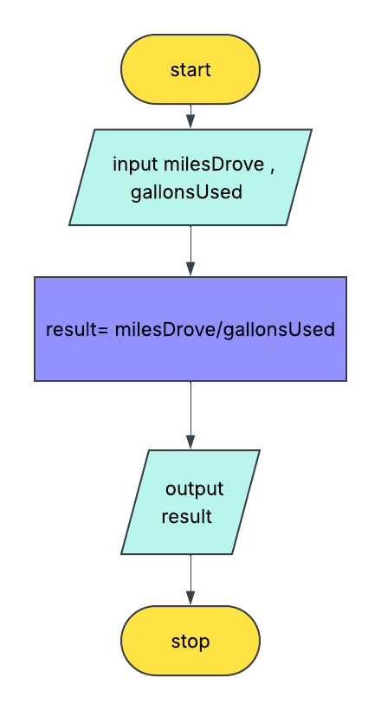
Copy Pseudocode Exercise 2: Compute daily rent costs here:

Copy Lucidchart Exercise 2: Compute daily rent costs here:
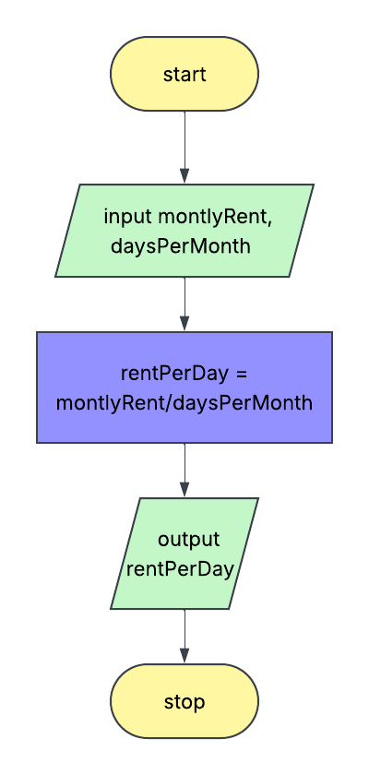
Copy Pseudocode Exercise 3: Think about a routine task or decision-making process in your daily life here:
Copy Lucidchart Exercise 3: Think about a routine task or decision-making process in your daily life here:


